**Journal Report 10**

**10/27/23**

I spent the whole class manually combing the dataset. I have looked through about 50 individual experiments and was able to graph some of them as shown below.

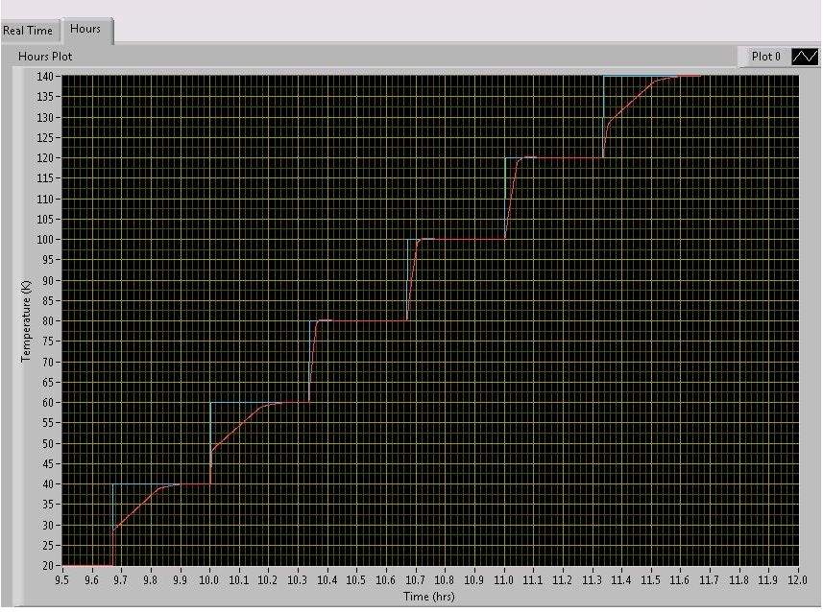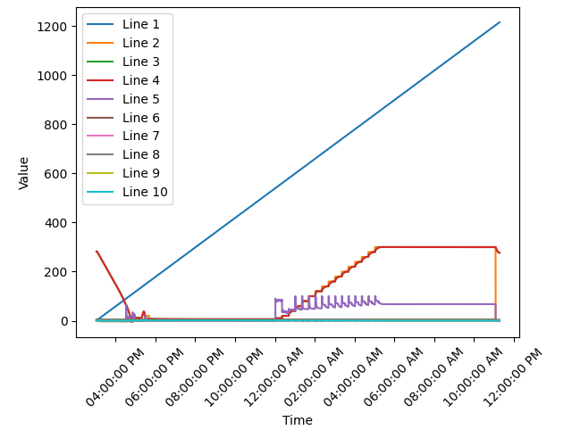

The majority of the data looks normal, but there are many experiments where data is sparse. Specifically, some of the experiments only go on for two or three hours, which is very unusual as the preparation stages of the CCR itself takes a couple of hours. I believe that there was some issue or an experiment was canceled leading to the short “experiment” time.

**10/30/23**

I finished preprocessing my dataset and so I uploaded to Kaggle for ease of access and organization. I had to write a python script that added an “id” attribute with each experiment having a distinct attribute in the TimeSeries object from the Darts library. I saved each experiment as a Time Series object because Darts is built for time series data and ensures that all components of a dataset are present. Some of the problems that might occur if you don’t use a Time Series object is having missing data or skipped time instances. Then, I pickled this dataset into a numpy array with this line of code:

**import** pickle

**with** open('timeseries_1000','wb') **as** f: pickle**.**dump(updated_list, f)

**11/1/23**

After uploading my datasets into Kaggle, I tried splitting my data into different segments with the different splits being 15 seconds, 1 minute, and 15 minutes. Afterwards, I started copying the code that I had written from my GAN demo with the Yahoo stock data. I spent the majority of the class changing the dataset so that there are only two variables: setpoint and temperature sensor A. I am hoping that my results from the GAN will be more accurate with less attributes and possibly conflicting variables. I also spent some time modifying the code so that it would read in my dataset. However, I am still in the process of updating my dataset, which I hope to finish by Monday.